Download this plug-in for Premiere Pro – WebM (windows or mac):
https://fnord.com/

Install the plug-in.

Enter Premiere Pro, export your footage that has alpha channel:
Format: WebM
Match Source.
Codec: VP8
V for Include Alpha Channel.
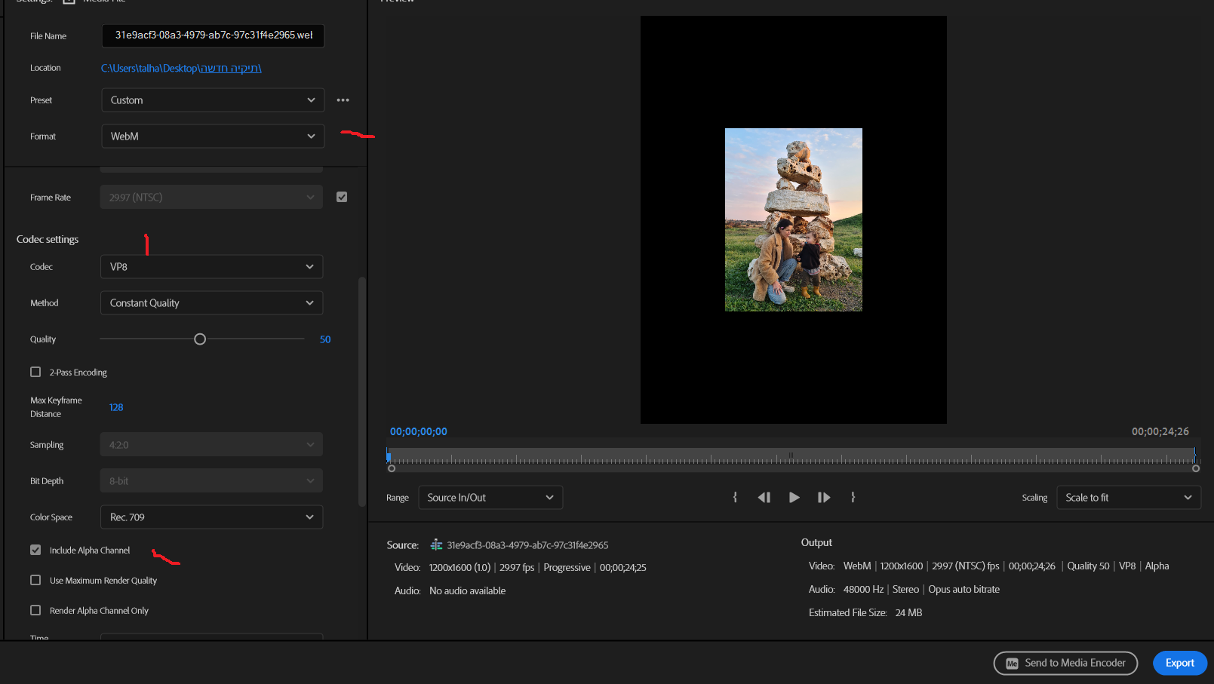

Import the exported video file into Unity.

In Unity, press on the video file, and in the Inspector, under the Default tab - tick V for "Transcode" and "Keep Alpha":
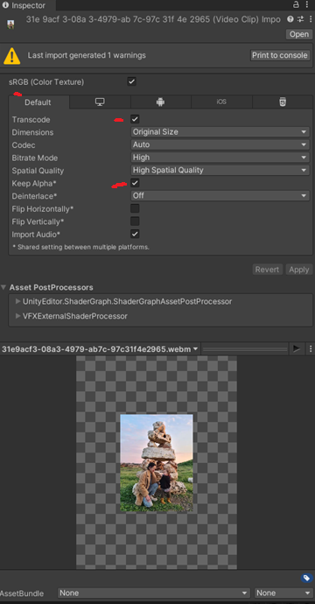

Create a New Material in Unity, click V on Alpha Clipping to make the material support Alpha.
Create a Quad, add the Video Player component to it.
Drag your video file into the video player component.
Drag the Video Material you made onto the Quad.

Walla! It will now play a video with alpha in Unity! Amazing!

